

**US Army Corps of Engineers**

**Afghanistan Engineer District**

AED Design Requirements:

Site Layout Guidance

Various Locations, Afghanistan

MARCH 2009

**TABLE OF CONTENTS**

AED DESIGN REQUIREMENTS FOR

SITE LAYOUT GUIDANCE VARIOUS LOCATIONS, AFGHANISTAN

Section Page

**1. General 1**

**2. Site Layout 1**

**3. Building Location 1**

a) Dimensional Factors 1 b) Environmental Factors 1 c) Orientation Factors 1 d) Other Siting Factors 1

**4. Vehicular Circulation 1**

a) Access Intersections 2 b) Controlled Entrances 3 c) Sight Distances 3

**5. Parking 4**

**6. Pedestrian Circulation 4**

**7. Utility System Design 5**

a) Utility Separation 5

**8. Physical Security 6**

a) Standard 1. Standoff Distance 6 b) Standard 2. Unobstructed Space 11 c) Standard 3. Drive-Up/Drop-Off Areas 11 d) Standard 4. Access Roads 12 e) Standard 5. Parking Beneath Buildings or on Roofs 12

**11. As-Builts 12**

Figures

Figure 1. Standoff Distance – Controlled Perimeter 8

Figure 2. Standoff Distance – No Controlled Perimeter 8

Figure 3. Parking and Roadway Control for Existing Buildings 9

– Controlled Perimeter

Figure 4. Parking and Roadway Control for Existing Buildings 9

- No Controlled Perimeter

Tables

Table 1. Dimensions for Design Vehicles 2

Table 2. Minimum Turning Radii for Design Vehicles 2

Table 3. Minimum Drive Spacing for Arterial Roads with Limited Access 3

Table 4. Minimum Sight Distance 3

Table 5. Standoff Distances for New and Existing Buildings 7

**1. General**

The purpose of this document is to provide requirements to Contractors for any project requiring site layout design and construction.

**2. Site Layout**

The site layout defines building location, vehicular circulation and parking, pedestrian circulation, utility systems design, and physical security. It also includes the identification and evaluation of the site layout. Identification includes defining site specific goals and objectives, verifying the program requirements, developing functional relationships, defining spatial relationships, and providing an inventory of the area. Evaluation includes the development of a site analysis that graphically shows the developmental opportunities and constraints for the site. Alternative conceptual plans are developed for evaluation and a determination of a final site plan is accomplished. The resulting site layout provides the basis for the preparation of construction drawings. The design criteria discusses building design, location and orientation, vehicular circulation and parking, pedestrian circulation, surface water management, utility systems design, lighting design, landscape design, and physical security.

**3. Building Location**

The building location on the site may be determined by considering the following factors.

**a) Dimensional Factors.** Dimensional factors include the building dimensions or footprint and the following factors:

1) Buffer Zones. Buffer zones provide setbacks and safety protection from airfield and helipad, explosive storage areas and storage and handling of hazardous materials. Additionally, buffer zones provide noise abatement and separation of incompatible land use or functions as well as physical security clearances.

2) Spacing Requirements. Spacing between buildings and functions is normally determined by their functional relationships, operational efficiency, fire protection clearances, physical security requirements, parking requirements, future expansion requirements, and open space requirements.

**b) Environmental Factors.** The location and condition of such elements as geology, soils, drainage, and vegetation may create areas that should be excluded from development because they are unbuildable for structural, economic or environmental reasons, they require protection or they require preservation.

**c) Orientation Factors.** Building location may be influenced by orientation to enhance energy conservation. Orientation to take advantage of or reduce the impact of prevailing winds and solar radiation should be considered when siting buildings.

**d) Other Siting Factors.** Other site-specific conditions can influence building alignment such as the ability to accomplish the mission, ability to minimize travel time and the ability to control access.

**4. Vehicular Circulation**

Circulation should promote safe and efficient movement of vehicles and pedestrians. Maintaining maximum separation of vehicles and pedestrians helps promote safety. Safe roadway circulation systems have a perceivable hierarchy of movement, lead to a clear destination and do not interrupt other activities. The road system should be planned to keep groupings of related functions reasonably close to each other and the interrelating land-use areas for maximum efficiency. Additionally, the road system should minimize on site travel and permit the optimum circulation of traffic originating both outside and

within the site. The American Association of State Highway and Transportation Officials (AASHTO) places vehicles into two general classes: passenger cars and trucks. The passenger car class includes passenger cars, and light delivery trucks such as vans and pickups. The truck class includes single-unit trucks, recreation vehicles, buses, trucks semi-tractor trailer combinations, and trucks or truck tractors with semi-trailers in combination with full trailers. Roadway layout to provide the maneuverability and traffic safety required by the vehicles that utilize the roadways is necessary. Table 1 lists dimensions for some of the more common vehicles. Table 2 lists minimum turning radii for the same vehicles.

Table 1. Dimensions for Design Vehicles

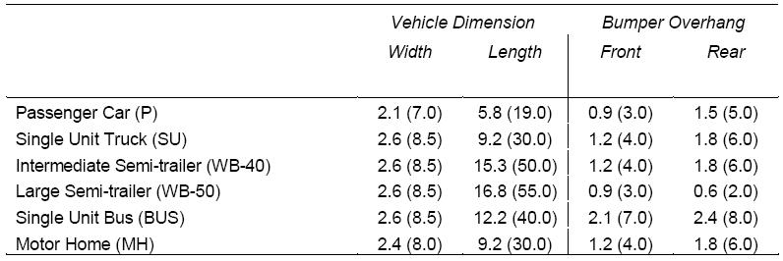

Table 2. Minimum Turning Radii for Design Vehicles

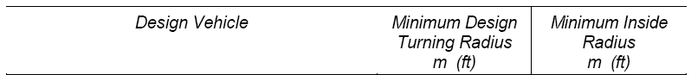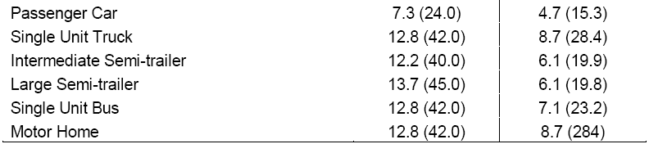

Design site entrances and exits, services drives, and other areas with special requirements (e.g., parking lots or loading docks) to accommodate the largest vehicle that will use the facility. This procedure should assure that traffic safety will be accommodated.

**a) Access Intersections.** Access intersections should be controlled to minimize the conflicts between through traffic on the main road and vehicles entering and exiting the site. Proper layout of access intersections may reduce conflicts between the traffic entering the site and the through traffic aon the main road. Points of conflict can be limited by the following:

Reducing the number of access drives to one (1) two-way drive or a pair of one-way drives for each site. Drives may be added to the site if the daily traffic volume exceeds 5,000 vehicles per day (both directions) or if traffic using one drive would exceed the capacity of a stop-sign-controlled intersection during the peak (highest) traffic hour.

Increasing the space between access intersections and between access intersections and roadway intersections. The correct spacing of access drives will promote safety for vehicular traffic. For arterial roads where access to the road is not limited, the minimum spacing between access roads should be 61 m (200 ft). Table 3 provides acceptable minimum spacing requirements when frontage along an arterial road is limited. Maintain a minimum spacing of 366m to 457m (1,200 to 1,500 ft) between a signaled drive and adjacent signaled intersection. If the signaled drive is a T-intersection, 183m (600 ft) is an acceptable minimum spacing when frontage is limited. Coordinate drive signals within 762m (2,500 ft) of adjacent signals. Maintain a minimum spacing of 10.5m to 15.5m (35 to 50 ft) on low-volume (5,000 vehicles per day), low-speed (48 kph (30 mph)) roads.

Table 3. Minimum Drive Spacing for Arterial Roads with Limited Access

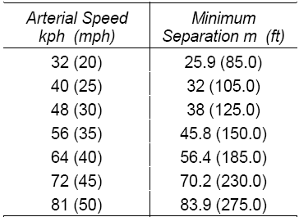

Access drives near major intersections adversely affect traffic operations. They may result in unexpected conflicts with vehicles turning at the intersection. Maintain a minimum clearance of 15.2m (50 ft) between access drives and major intersections.

Provide adequate road width and length along the access drive at the intersection to channel vehicles smoothly into the proper lanes. Providing left-turn lane and right-turn and acceleration lane on the main roadway at the access drive.

**b) Controlled Entrances.** Controlled entrances are to be provided at the entrance to large complexes or secure facilities. Controlled entrances should contain a traffic island, gates and a way to have the

vehicles denied entrance to the site an exit without entering the site. The traffic island with curbs should be a minimum of 3.1 meters wide and shall be used to separate incoming and outgoing traffic. A gate

house may be provided within the area of the traffic island. The minimum throat length should be long

enough to accommodate stacking of vehicles entering and exiting the site without interfering with the traffic flow on adjacent roads. A pull-off area should be provided on the incoming traffic lanes for the close inspection of vehicles prior to entering the site.

**c) Sight Distances.** Provide safe sight distance for vehicles entering and exiting an access drive. This sight distance increases according to the design speed of the through road. The relationships of speed to sight distances are provided in Table 4.

Table 4. Minimum Sight Distance

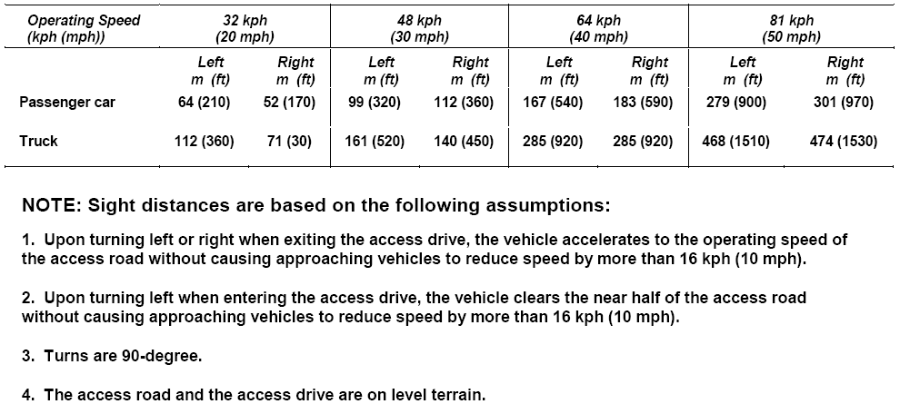

When a safe sight distance cannot be met, the designer should consider methods to achieve adequate sight distance. Some methods of achieving adequate sight distance are the removal of sight

obstructions, the relocation of the access drive to a more favorable location along the access street or the relocation of the access drive to another access road.

**5. Parking**

Parking includes on-street parking, off-street parking lots, and parking structures. On-street parking will be limited to parallel parking spaces that include sufficient length and width to allow safe movement into and out of the space and to adequately separate the parked vehicle from the traffic lanes. All parking areas should be within close walking distance of the building that they serve. A recommended minimum

6m wide buffer strip should be provided to separate parking areas from adjacent streets. In areas of limited space provide a minimum distance of 2.4m may be provided.

Off-street parking lots are the principal means of parking on installations. A 90-degree parking layout is preferable. Where a fast rate of turnover is expected or where required by site limitations, a 45-degree or

60-degree angle layout may be used. Design the parking layout to provide regular parking (2.75m x

5.80m) and handicapped parking spaces (4.25m x 5.80m). Such features as curb cuts and access aisles for barrier-free access to sidewalks should be included for handicapped access. The maintenance of

two-way traffic in parking lots is encouraged. Dead end parking lots should be avoided. Provide more than one entrance and exit for parking lots with more than 100 parking spaces. Curbs or a painted line at

the end of parking stalls should be used to control placement of vehicles. Provide adequate walkway width to allow comfortable pedestrian movement in areas of bumper overhang. The minimum turning

radii should accommodate the largest vehicle expected to use the parking lot as identified in Table 2.

Locate islands at the ends of parking stalls and at the intersections of parking aisles. Medians may be placed between adjacent rows of parking stalls. The islands establish turning radii for vehicular movement and protect end stalls. Turning radii to be used is based upon the largest vehicle that will utilize the

parking lot. Include turning radii that is sufficient to allow safe traffic movement without conflicting with the island and/or curbing. Islands and medians can be partially or completely paved to service pedestrian traffic. Pedestrians tend to use circulation aisles, especially if medians are not generous and do not allow

for comfortable movement between vehicles. If the median is designed as a sidewalk, provide a width that

allows for pedestrian movement and vehicle overhang.

Landscaping in islands and medians should be considered to break up the expanse of impermeable and unshaded surface, provide a more pleasing visual and spatial appearance. When placing landscaping in islands or medians, the designer should consider the 1.07m motorist eye level viewing height when providing shrubs and small trees.

Grading of parking lots should maintain a relatively constant grade across the lot that includes no less than the minimum slope of one (1) percent required for positive drainage to properly direct drainage to swales or to drainage inlets. The maximum slope within a 90-degree parking space of five (5) percent from front to rear end of the vehicle and one and one-half (1 ½) percent from side to side. Provide a maximum slope within a 45-degree or 60-degree parking space of five (5) percent from front to rear end and one (1) percent from side to side. Islands and medians may be used to accommodate change in elevation between the access drive and parking areas or between different parking levels.

**6. Pedestrian Circulation**

Pedestrian circulation involves the movement of people by non-motorized means along sidewalks. Pedestrian circulation should be based on pedestrians' tendency to follow the most direct route when walking between two points. Sidewalk paths may be gridded, curvilinear or organic. Paths should incorporate required and anticipated access. All three systems provide functional access between facilities. Topography and vegetation can be used to direct movement and emphasize sight lines along paths.

A grid path system is composed of straight lines and right angles and tends to provide the most direct access between locations. The grid system is appropriate in formal landscapes and in areas with strong

architectural definition. A curvilinear path system is less formal and should be used to encourage pedestrian interaction with the landscape where direct access to facilities is not critical. Organic sidewalk systems are unique in that the sidewalk patterns are defined by the space outside of the sidewalk and therefore vary in width. Because of this, organic sidewalks are less formal and often respond to natural elements in the surrounding landscape.

The space required to accommodate pedestrian movement increases at the point of origin and destination, where movement slows. Pedestrian movement is also interrupted when people meet, gather, wait, or sit. In areas of pedestrian concentration (e.g., building entrances, drop-offs and small outdoor spaces between buildings), the space should be developed to accommodate these needs. General design techniques include widening walkways at the points of origin and destination and providing both shaded and sunny areas for people to congregate or sit on the edge or outside of the pedestrian flow.

Sidewalks should be provided with a smooth and hard surface such as concrete, asphalt or pavers. The minimum width of the sidewalk should be 1.2 meters. As the amount of traffic increases on a sidewalk, the width should be adjusted accordingly. The grade of a sidewalk should follow the natural grade of the ground as nearly as possible. The longitudinal grade along the sidewalk should not be greater than about

12 percent with the cross-slope of the sidewalk not greater than 2.08 percent. Steps should be avoided if possible but will be used where the maximum longitudinal slope would otherwise be too great. Steps should be grouped together rather than spaced as individual steps. Where steps are required, consideration should be given to handicapped ramps to provide continuous handicapped accessability. Sidewalks should be separated from roads by a turfed area at least 0.6 meters wide for low speed roads. As the speed of the roadway increased, the separation distance between the sidewalk and the roadway should increase.

**7. Utility System Design**

Utility systems should minimize impact to the natural site while meeting basic economic and functional criteria. Utility corridors should be used to minimize environmental disturbance and simplify maintenance. These corridors should be located along a site's perimeter and not cross a site diagonally or indiscriminately because future realignment of existing systems will increase the costs of future development. Utilities should be placed underground wherever possible to avoid conflicts with

vegetation, provide protection from storm damage, and enhance the visual quality of the installation. To simplify maintenance, utility lines should not be placed under paved areas, but located at the back of the roadway curb. It is extremely important to determine the potential for future expansion and to allow for upgrading the system when locating utilities. Utility transformers and transclosures for underground utilities shall be located to ensure ease of access for maintenance but not obstruct site primary visual relationships. They should be located with adequate setbacks from vehicular circulation and parking areas.

**a) Utility Separation.** Water mains should have a minimum horizontal clearance of 3.05 meters from any point of an existing or proposed sanitary sewer or storm drain line. Water mains and sanitary sewers must not be installed in the same trench. If any condition prevents a horizontal separation of 3.50 meters, a minimum horizontal separation of 1.80 meters can be allowed with the bottom of the water main a minimum of 0.30 meters above the top of the sanitary sewer line. Where water mains and sanitary

sewers follow the same roadway, they will be installed on opposite sides of the roadway, if possible. Where water mains and sewer lines cross, the sewer line will have no joints within 0.91 meters of the water main unless the sewer line is encased in concrete for a distance of at least 3.05 meters each side

of the crossing. If conditions dictate that a water main be laid under a gravity sewer, the sewer pipe will

be fully encased in concrete for a distance of 3.05 meters each side of the crossing or will be made of pressure pipe with no joint located within 0.30 meters horizontally of the water main. Pressure sewer pipe will always cross beneath water pipes with a minimum vertical distance of 0.60 meters between the

bottom of the water pipe and the top of the pressure sewer pipe.

**8. Physical Security**

Operational, logistic, and security requirements must be integrated into the overall design of buildings, equipment, landscaping, parking, roads, and other features. The most cost-effective solution for mitigating explosive effects on buildings is to keep explosives as far as possible from them. Standoff distance must be coupled with appropriate building hardening to provide the necessary level of protection. The following standards detail standoff distances that when achieved will allow for buildings to be built with minimal additional construction costs. Where these standoff distances cannot be achieved because land is unavailable, these standards allow for building hardening to mitigate the blast effects.

**a) Standard 1. Standoff Distances.** The standoff distances apply to all new and existing (when triggered) buildings covered by these standards. The standoff distances are presented in Table 5 and illustrated in Figures 1 and 2 for new buildings and Figures 3 and 4 for existing buildings. Where the standoff distances in the “Conventional Construction Standoff Distance” column of Table 5 can be met, conventional construction may be used for the buildings without a specific analysis of blast effects, except as otherwise required in these standards.

Where the conventional construction standoff distances are not available, an engineer experienced in blast-resistant design should analyze the building and apply building hardening as necessary to mitigate the effects of the explosives indicated in Table 5 at the achievable standoff distance to the appropriate level of protection.

For new buildings, standoff distances of less than those shown in the “Minimum Standoff Distance” column in Table 5 are not allowed. For existing buildings, the standoff distances in the “Minimum Standoff Distance” column of Table 5 will be provided except where doing so is not possible. In those cases, lesser standoff distances may be allowed where the required level of protection can be shown to be achieved through analysis or can be achieved through building hardening or other mitigating construction or retrofit.

**1) Controlled Perimeter.** Measure the standoff distance from the controlled perimeter to the closest point on the building exterior or inhabited portion of the building.

**2) Parking and Roadways.** Standoff distances for parking and roadways are based on the assumption that there is a controlled perimeter at which larger vehicle bombs will be detected and kept from entering the controlled perimeter. Where there is a controlled perimeter, the standoff distances and explosive weight associated with parking and roadways in Table 5 apply. If there

is no controlled perimeter, assume that the larger explosive weights upon which the controlled perimeter standoff distances are based (explosive weight I from Table 5) can access parking and roadways near buildings. Therefore, where there is no controlled perimeter, use standoff

distances from parking and roadways according to the distances and the explosive weight

associated with controlled perimeters in Table 5. Measure the standoff distance from the closest edge of parking areas and roadways to the closest point on the building exterior or inhabited portion of the building.

Table 5. Standoff Distances for New and Existing Buildings

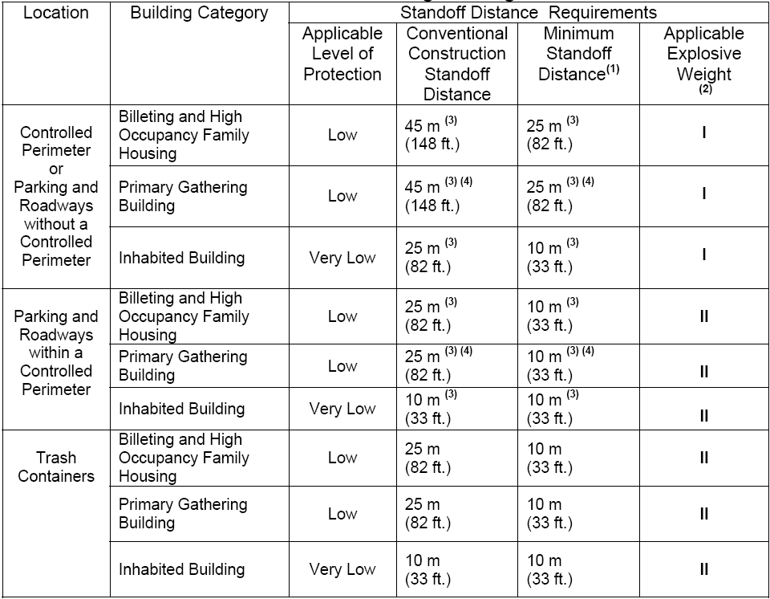

The minimum standoff distance for all new buildings regardless of hardening or analysis is the minimum standoff distance in Table 5 for both parking areas and roadways. Where possible, move parking and roadways away from existing inhabited buildings (including leased buildings) in accordance with the standoff distances and explosive weights in Table 5. It is recognized, however, that moving existing parking areas and roadways or applying structural retrofits may be impractical; therefore, the following operational options are provided for existing inhabited buildings.

Controlled parking associated with existing inhabited buildings may be allowed to be as close as the minimum standoff distance in Table 5 without hardening or analysis if access control to the parking

Figure 1. Standoff Distance – Controlled Perimeter

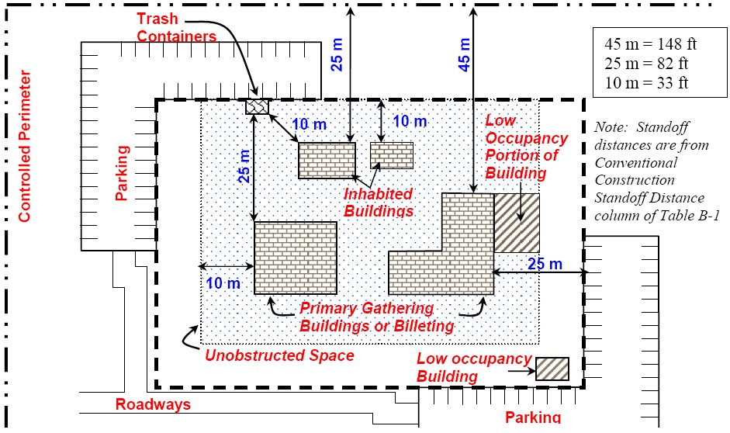

Figure 2. Standoff Distance – No Controlled Perimeter

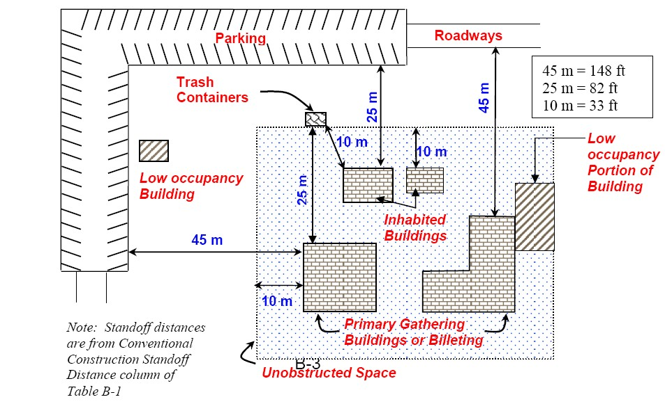

Figure 3. Parking and Roadway Control for Existing Buildings - Controlled Perimeter

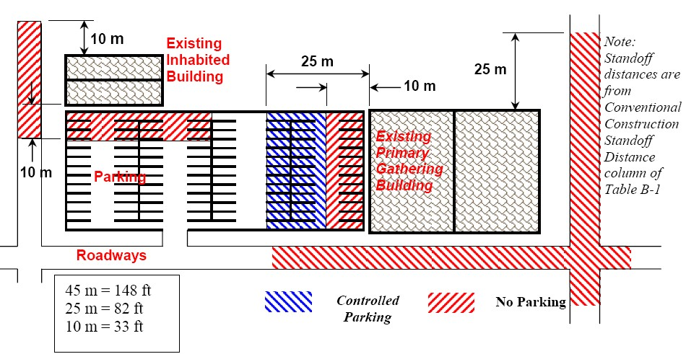

Figure 4. Parking and Roadway Control for Existing Buildings - No Controlled Perimeter

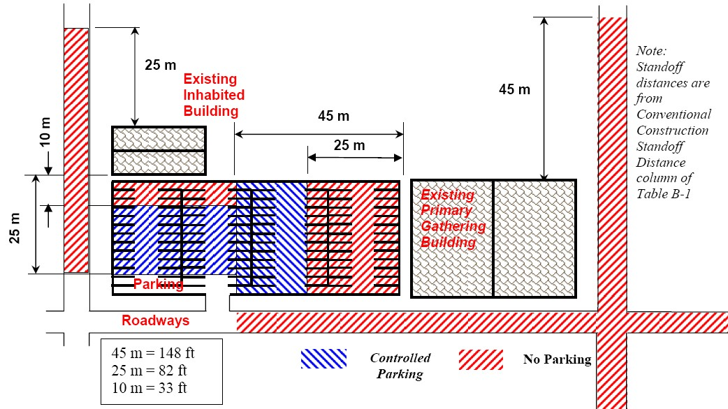

The minimum standoff distance for all new buildings regardless of hardening or analysis is the minimum standoff distance in Table 5 for both parking areas and roadways.

**3) Existing Inhabited Buildings.** Where possible, move parking and roadways away from existing inhabited buildings (including leased buildings) in accordance with the standoff distances and explosive weights in Table 5. It is recognized, however, that moving existing parking areas and roadways or applying structural retrofits may be impractical; therefore, the following operational options are provided for existing inhabited buildings.

Controlled parking associated with existing inhabited buildings may be allowed to be as close as the minimum standoff distance in Table 5 without hardening or analysis if access control to the parking area is established at the applicable conventional construction standoff distance for parking in Table 5. In cases where the applicable level of protection can be provided (based on hardening or analysis) with a standoff distance between the conventional construction standoff distance and the minimum standoff distance, parking may be allowed as close as the minimum standoff distance in Table 5 if parking is controlled at that lesser applicable standoff distance

subject to the following:

Parking Within a Controlled Perimeter. The applicable conventional construction or minimum standoff distance at which access will be controlled will be based on the standoff distances for parking and roadways within a controlled perimeter in Table 5 and illustrated in Figure 3 for the applicable building category.

Parking Without a Controlled Perimeter. The applicable conventional construction or minimum standoff distance at which access will be controlled will be based on the

standoff distances for parking and roadways without a controlled perimeter in Table 5 and illustrated in Figure 4 for the applicable building category.

Alternate Situations. Controlled parking may be allowed to be closer to existing inhabited buildings where conditions necessitate it and where it can be shown through analysis that the required level of protection can be provided at a lesser standoff distance or if it can be provided through building hardening or other mitigating measures or retrofits. Allowing

any parking closer than the distances established in the paragraphs above should be avoided wherever possible, however.

Parking along roadways is subject to the same standoff considerations as other parking. Ensure that there is no parking on roadways within the required standoff distances (conventional construction or minimum in accordance with Table 5 and illustrated in Figures 3 and 4) along existing roads adjacent to existing buildings covered by these standards.

For high occupancy family housing within a controlled perimeter or where there is access control to the parking area, parking within the required standoff distances may be allowed where designated parking spaces are assigned for specific residents or residences. Do not label assigned parking spaces with names or ranks of the residents, however. Do not encroach upon existing standoff distances where the existing standoff distances are less than the required (conventional construction or minimum in accordance with Table 5) standoff distances. For example, where existing designated parking is only 8 meters from existing family housing, that parking may be retained, but additional parking will not be allowed closer than 8 meters.

**4) Parking of Emergency, Command and Operations Support Vehicles.** Emergency and command vehicles, as well as operations support vehicles may be parked closer to inhabited buildings than allowed in Table 5 without hardening or analysis if access to them is continuously controlled or as long as they are never removed from a restricted access area, but they may not be parked closer than the distance associated with unobstructed spaces as established in Standard 2. In addition, where standard operation of buildings includes parking emergency vehicles inside them, such as in fire stations, those emergency vehicles may be parked inside the buildings where necessary as long as access to the building is controlled.

**5) Parking of Vehicles Undergoing Maintenance.** Vehicles undergoing maintenance may be parked inside maintenance buildings closer to inhabited areas of those buildings than allowed in Table 1 while they are undergoing repair where operationally necessary.

**6) Adjacent Existing Buildings.** Where projects for new and existing buildings designed in accordance with these standards include locating parking, roadways, or trash containers near existing inhabited buildings that are not required to meet these standards, the standoff distances from parking, roadways, and trash containers to the buildings that are not required to comply with these standards should comply with the applicable standoff distances in Table 5. Where those standoff distances are not available, do not allow the parking, roadways, and trash containers to encroach on existing standoff distances to the parking, roadways, and trash containers associated with those existing buildings. For example, if existing parking associated with an existing inhabited building that does not have to comply with these standards is 10 meters from the building, do not allow new parking and roadways associated with a new building closer than

10 meters from the existing building.

**7) Parking and Roadway Projects.** Where practical, all roadway and parking area projects should comply with the standoff distances from inhabited buildings in Table 5. Where parking or roadways that are within the standoff distances in Table 5 from existing buildings are being constructed, expanded, or relocated, do not allow those parking areas and roadways to encroach on the existing standoff distances of any existing inhabited building. That applies even where

such projects are not associated with a building renovation, modification, repair, or restoration requiring compliance with these standards.

**8) Trash Containers.** Measure the standoff distance from the nearest point of the trash container or trash container enclosure to the closest point on the building exterior or inhabited portion of the building. Where the standoff distance is not available, harden trash enclosures to mitigate the direct blast effects and secondary fragment effects of the explosive on the building if the applicable level of protection can be proven by analysis or testing. Alternatively, if trash containers or enclosures are secured to preclude introduction of objects into them by unauthorized personnel, they may be located closer to the building as long as they do not violate the unobstructed space provisions of Standard 2. Openings in screening materials and gaps between the ground and screens or walls making up an enclosure must not be greater than 150 mm.

**b. Standard 2. Unobstructed Space.** It is assumed that aggressors will not attempt to place explosive devices in areas near buildings where these explosive devices could be visually detected by building occupants observing the area around the building. Therefore, ensure that obstructions within 10 meters of inhabited buildings or portions thereof do not allow for concealment from observation of explosive devices

150 mm or greater in height. This does not preclude the placement of site furnishings or plantings around buildings. It only requires conditions such that any explosive devices placed in that space would be observable by building occupants. For existing buildings where the standoff distances for parking and

roadways have been established at less than 10 meters in accordance with paragraph a.3, the

unobstructed space may be reduced to be equivalent to that distance.

**1) Electrical and Mechanical Equipment.** The preferred location of electrical and mechanical equipment such as transformers, air-cooled condensers, and packaged chillers is outside the unobstructed space or on the roof. However this standard does not preclude placement within the unobstructed space as long the equipment provides no opportunity for concealment of explosive devices.

**2) Equipment and Trash Container Enclosures.** If walls or other screening devices with more than two sides are placed around trash containers or electrical or mechanical equipment within the unobstructed space, enclose the trash containers or equipment on all four sides and the top. Openings in screening materials and gaps between the ground and screens or walls making up an enclosure will not be greater than 150 mm. Secure any surfaces of the enclosures that can be opened so that unauthorized personnel cannot gain access through them.

**c. Standard 3. Drive-Up/Drop-Off Areas.** Some facilities require access to areas within the required standoff distance for dropping off or picking up people or loading or unloading packages and other objects. Examples that may require drive-up/drop-off include, but are not limited to, medical facilities, exchanges and commissaries, child care centers, and schools.

1) **Marking.** Where operational or safety considerations require drive-up or drop-off areas or drive-through lanes near buildings, ensure those areas or lanes are clearly defined and marked and that their intended use is clear to prevent parking of vehicles in those areas.

2) **Unattended Vehicles.** Do not allow unattended vehicles in drive-up or drop-off areas or drive- through lanes.

3) **Location.** Do not allow drive-through lanes or drive-up/drop-off to be located under any inhabited portion of a building.

**d. Standard 4. Access Roads.** Where access roads are necessary for the operation of a building (including those required for fire department access), ensure that access control measures are implemented to prohibit unauthorized vehicles from using access roads within the applicable standoff distances in Table 5.

**e. Standard 5. Parking Beneath Buildings or on Rooftops.** Eliminate parking beneath inhabited buildings or on rooftops of inhabited buildings. Where very limited real estate makes such parking unavoidable, the following measures must be incorporated into the design for new buildings or mitigating measures must be incorporated into existing buildings to achieve an equivalent level of protection.

**1) Access Control.** Ensure that access control measures are implemented to prohibit unauthorized personnel and vehicles from entering parking areas.

**2) Structural Elements.** Ensure that the floors beneath or roofs above inhabited areas and all other adjacent supporting structural elements will not fail from the detonation in the parking area of an explosive equivalent to explosive weight II in Table 5.

**11. As-Builts**

Upon completion of installing the site features, The Contractor shall submit editable CAD format As-Built drawings. The drawing shall show the final product as it was installed in the field, with the exact dimensions, locations, materials used and any other changes made to the original drawings. Refer to Contract Sections 01335 and 01780A of the specific project for additional details.